**Competitive Forces**

**Disruptive Technology**

* Displaces and established technology and shakes up the industry which creates new standards for the industry
* Example: Analog Camera vs Digital Camera

**Supply Chains**

* Describes flow of materials, information, money and services from suppliers of raw material through factories, to end customers

**Competitive Advantage**

* **Competitive Strategy**: Business’ strategy to compete, its goals, and plans and policies that are required to achieve those goals.
* **Competitive Advantage:** Business seeks to outperform its competitors in some measure.
  + Helps a company control a market and generate better profit

**Porter’s Competitive Forces Model**

* Companies use these to develop strategies
* Also demonstrates how IT can make a company more competitive

**Threats of new entrants**

* High -> Easy to enter a market
* Low -> Significant barriers to entry exist
  + Barrier to entry: Product or service that customers expect from organizations
  + Internet increases threat

**Supplier Power**

* High -> when buyers have few choices
* Low -> when buyers have many choices
* Internet impact is mixed since buyers can shop around but then again suppliers can lock in customers this way.

**Buyer Power**

* High -> buyers have many choices
* Low -> Buyers have low choices
* Internet increases buyer power as it gives access to information
* Reduces switching costs: costs in money and time to buy elsewhere

**Threat of substitute products or services**

* High -> many substitutes for organization’s products
* Low -> Few substitutes for organization’s products
* Information-based industries suffer from this (i.e. music, books, software)
* There’s many possibilities with the internet to access these

**Rivalry**

* High -> when there’s fierce competition (duh)
* Low -> When there’s not (duh)

**Porter’s Value Chain Model**

* Used to identify specific activities for competitive strategies
* More specific than Porter’s Competitive Forces

**What’s a value chain?**

* A network of activities that improve effectiveness of a good or service
* The higher the value the company adds to a product the more money they make.
* Exmple: Rubber -> Tire -> Tire Store -> Mechanic installs tire

**Two categories**

* Primary Activities
  + Adds value directly to the product
  + Inbound Logistics(inputs)
  + Operations(Manufacturing and testing)
  + Outbound logistics(Storage and distribution)
  + Marketing and sales
  + After sales service
* Support Activities
  + Do not add value directly
  + Support primary activities

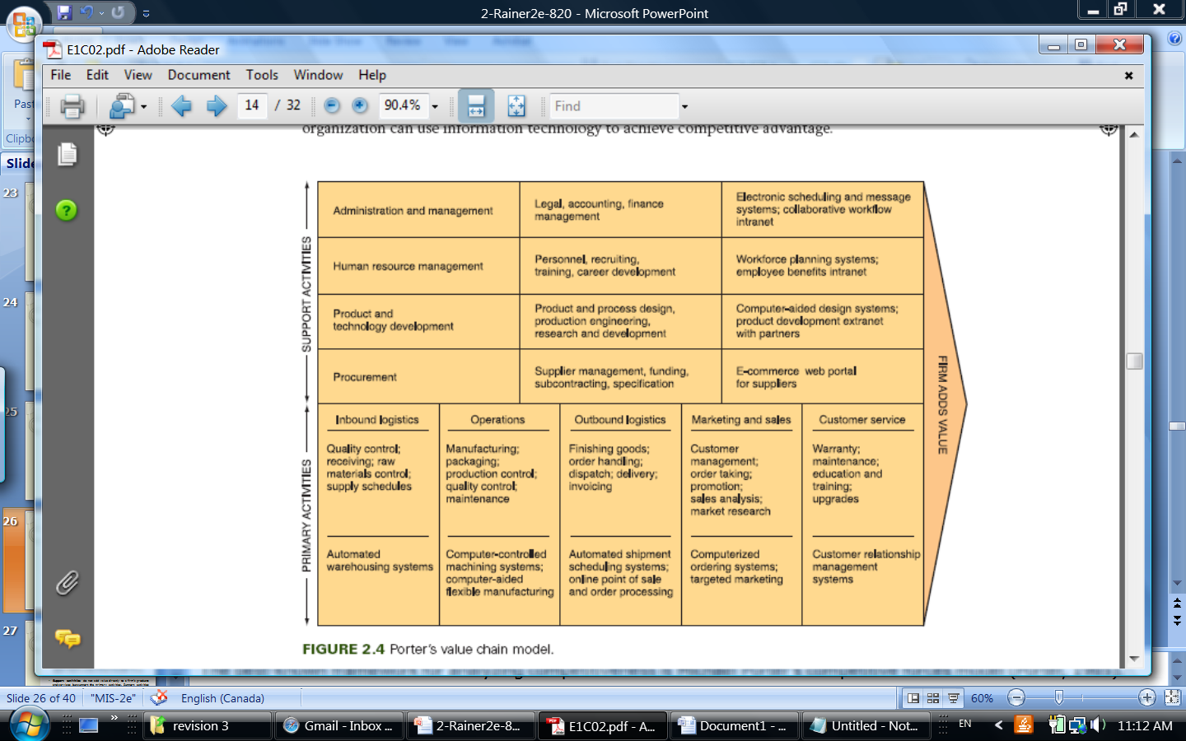

**Competitive Strategies**

* Companies continually try to develop strategies for the following 5 competitive forces
* **Cost Leadership:** Produce products or services at the lowest cost in the industry
* **Differentiation:** Offer different products, services or features
* **Innovation:** Introduce new products services, add new features, etc.
* **Operational Effectiveness:** Improve way that processes are executed. Perform similar activities better than rivals.
* **Customer-Orientation:** Concentrate on making customers happy ☺